10.8.24

Java questions

1.write a java program to create a class called shape with a method class called getarea().create a subclass called rectangle that overwrite the getarea() method to calculate the area of rectangle.

Code:

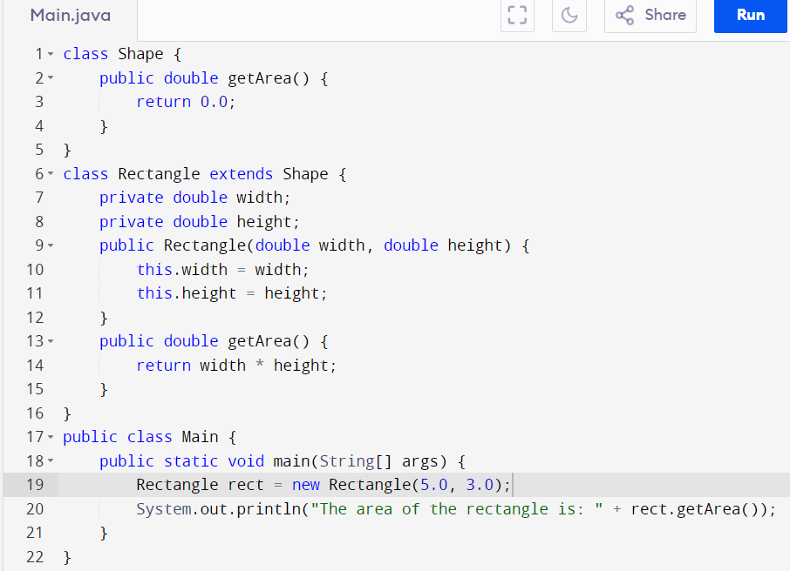

Output

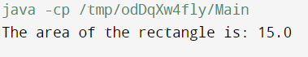

2. write a java program to create a class called employee with method word getsalary .create a subclass called hr manager that overwrite the method and add a new method called addemployee().

Code:

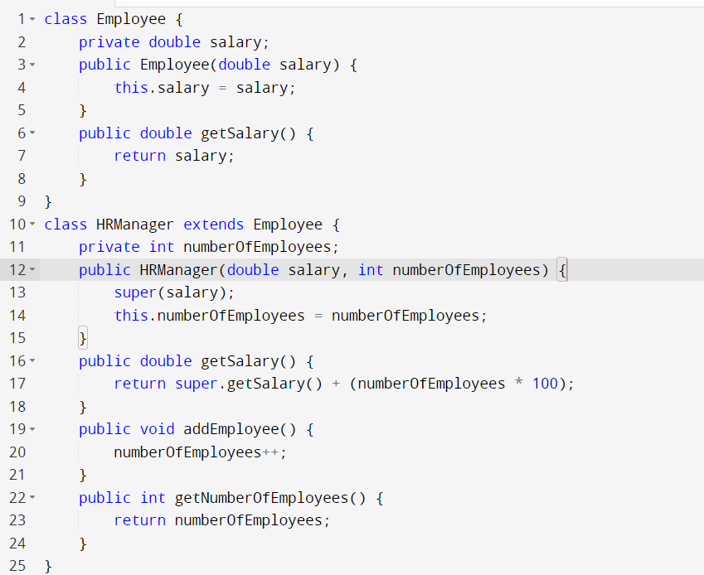

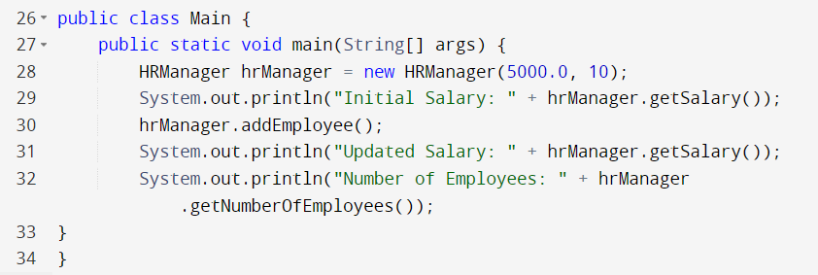

Output

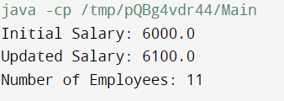

Abstract class here abstract is a keyword

3. Create an abstract class vehicle with both abstract and non abstract methods . implement a sub class car that extend vehicle and override the abstract the method.

Code

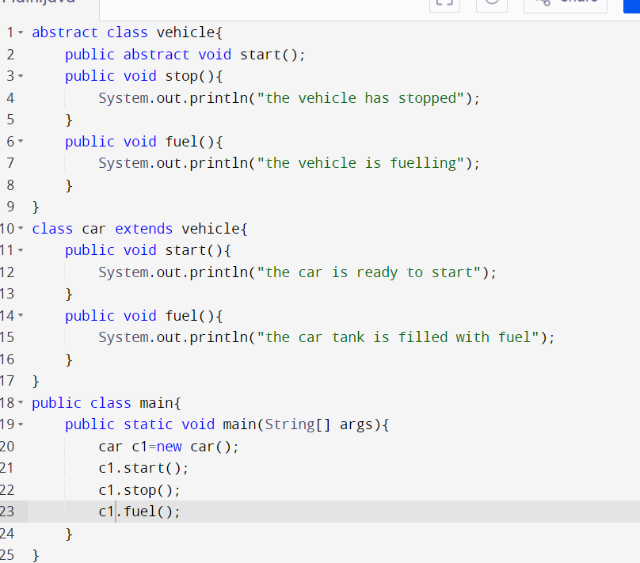

Output

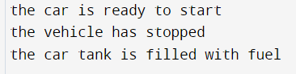

Add constructor super with arguments

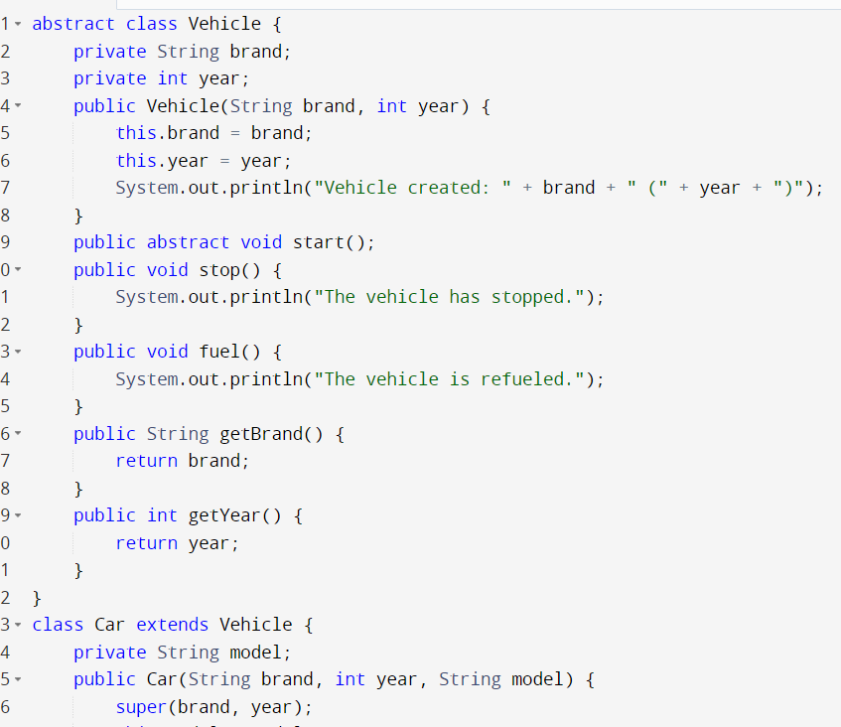

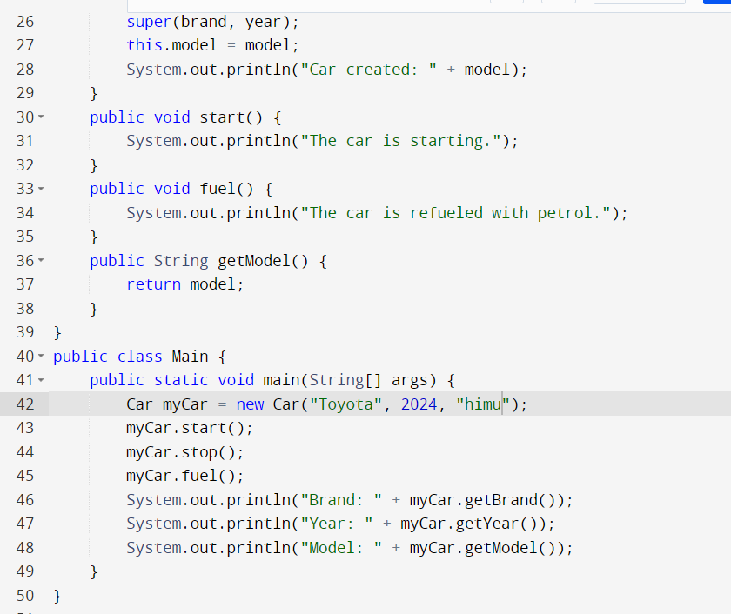

Output

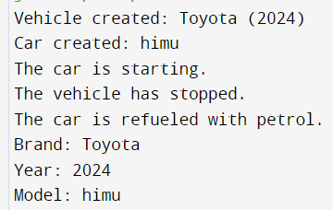

Add constructor super without arguments

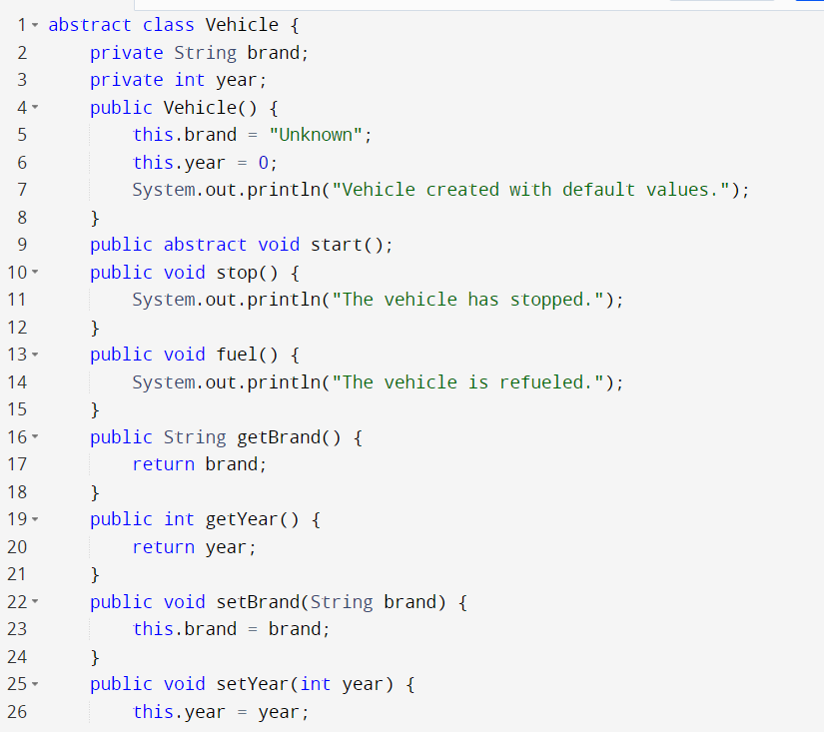

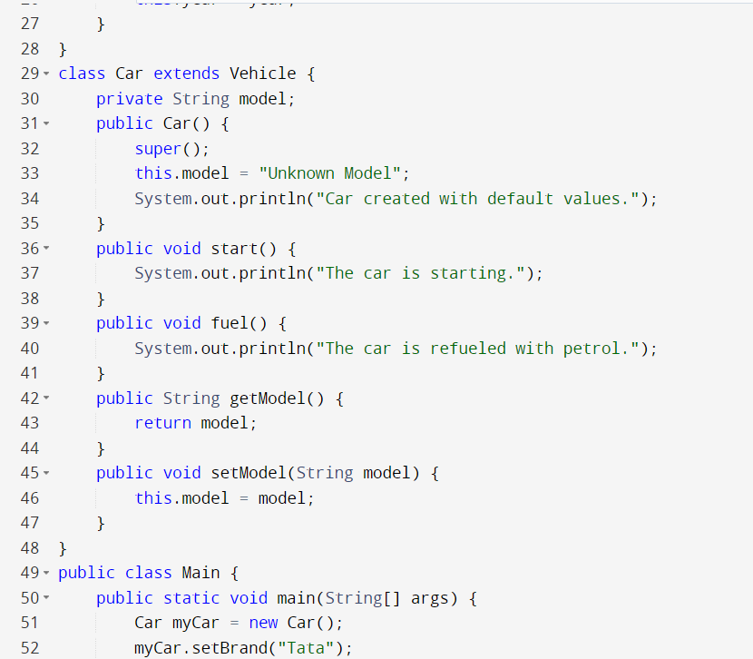

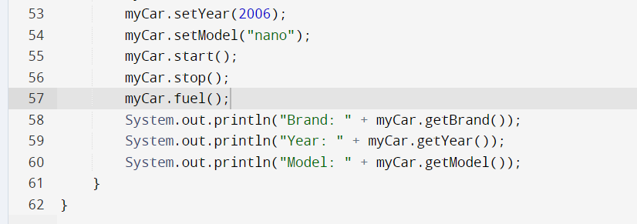

Output

